Poročilo Algoritmov

# Weka

## Iris

### IBK

### Naive Bayes

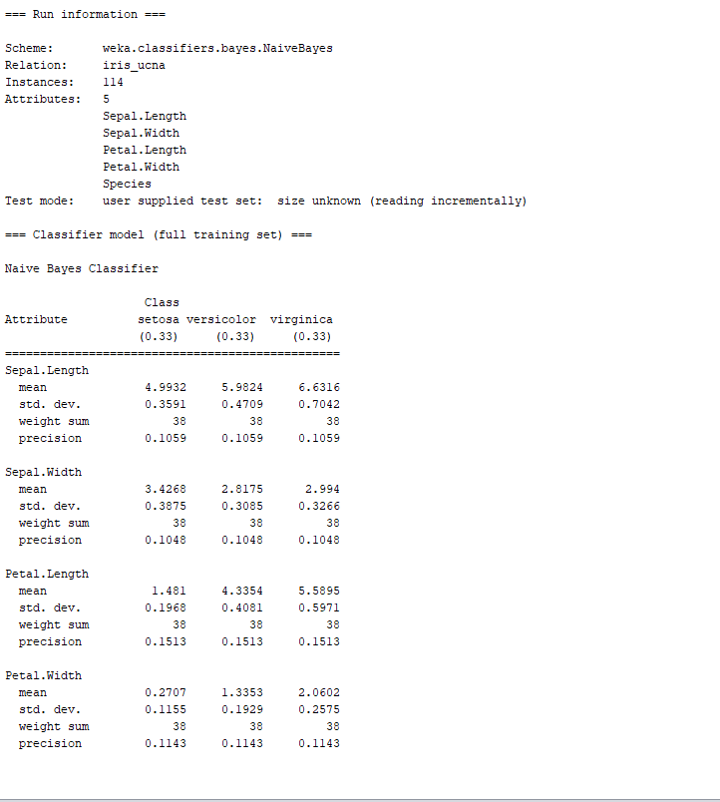

### J48

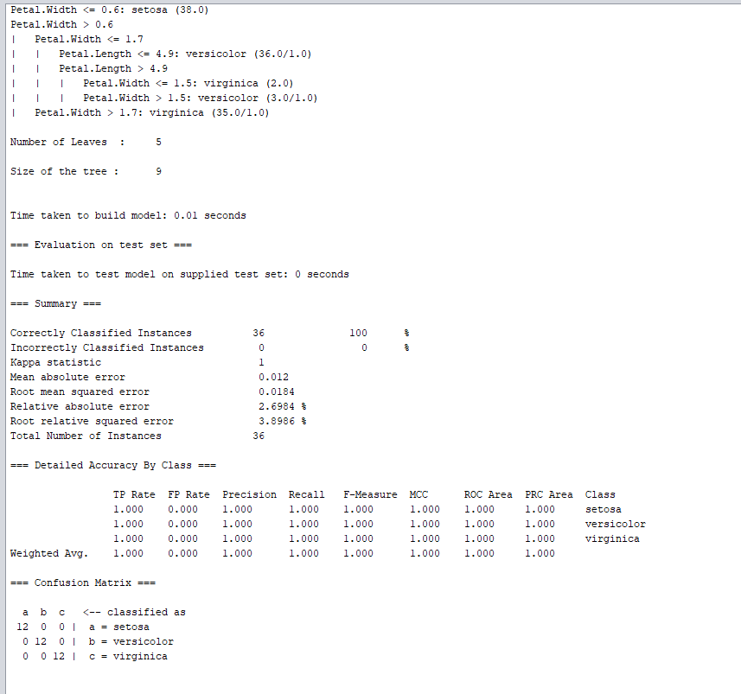

### Multilayer Perceptron

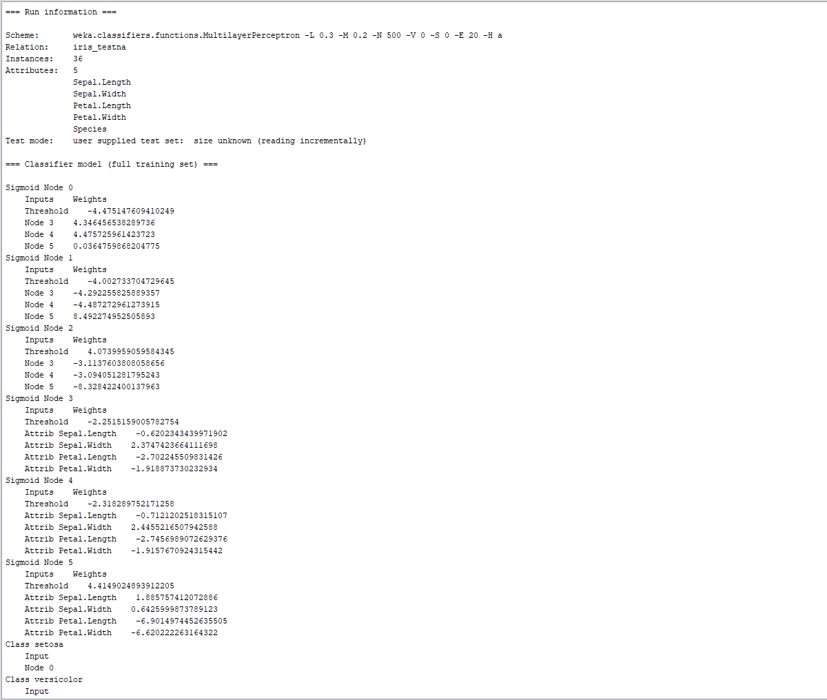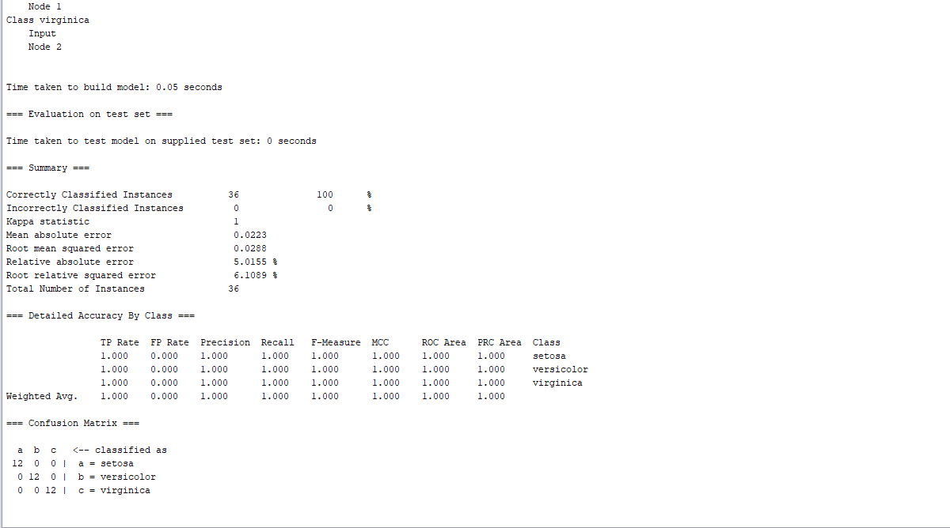

## Wine

### IBK

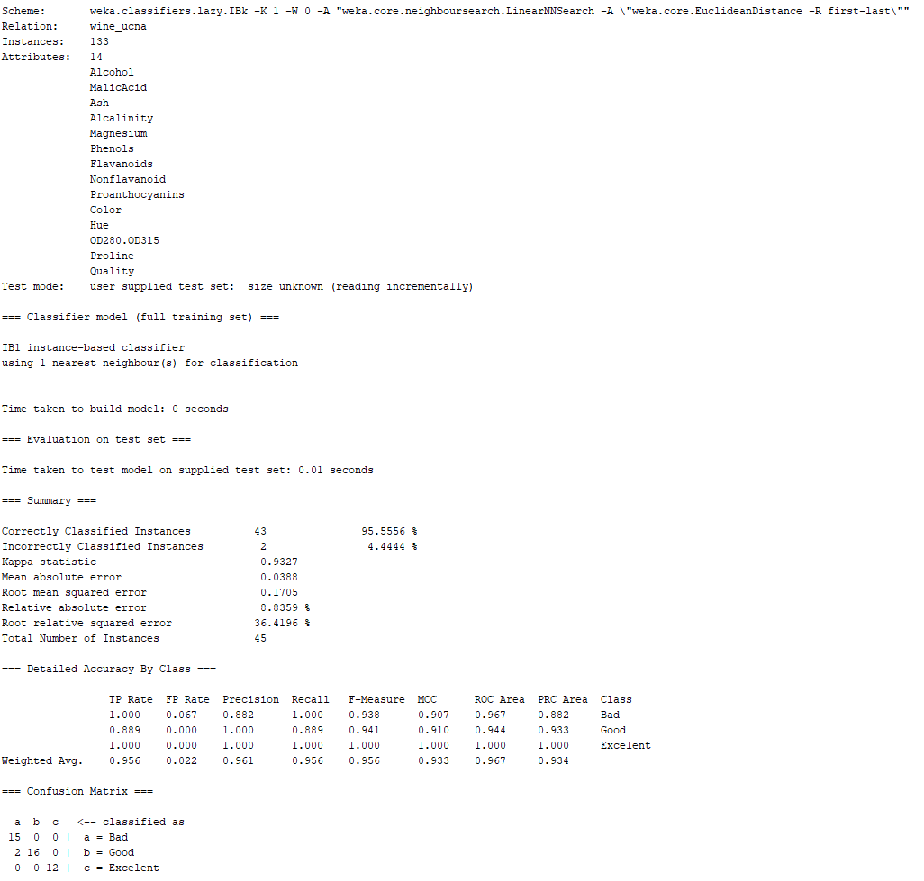

### Naive Bayes

### J48

### Multilayer Perceptron

=== Run information ===

Scheme: weka.classifiers.functions.MultilayerPerceptron -L 0.3 -M 0.2 -N 500 -V 0 -S 0 -E 20 -H a

Relation: wine_ucna

Instances: 133

Attributes: 14

Alcohol

MalicAcid

Ash

Alcalinity

Magnesium

Phenols

Flavanoids

Nonflavanoid

Proanthocyanins

Color

Hue

OD280.OD315

Proline

Quality

Test mode: user supplied test set: size unknown (reading incrementally)

=== Classifier model (full training set) ===

Sigmoid Node 0

Inputs Weights

Threshold -1.5331432595026016

Node 3 -3.3975425398564534

Node 4 2.8654448271738677

Node 5 1.4481417185100527

Node 6 -5.918038297759341

Node 7 3.453365807045028

Node 8 -0.8912904566760799

Node 9 2.937136656354985

Node 10 -1.7525218128689208

Sigmoid Node 1

Inputs Weights

Threshold -2.6210941775520076

Node 3 -4.795429935548074

Node 4 -3.4608810872129467

Node 5 0.2909907111167406

Node 6 5.619160873552804

Node 7 -3.660244038153453

Node 8 4.872185435472002

Node 9 -2.32384562062192

Node 10 0.745390872964294

Sigmoid Node 2

Inputs Weights

Threshold 1.6523959709434495

Node 3 5.409151030156572

Node 4 -0.7455589317424399

Node 5 -2.737393270008436

Node 6 -1.7380410515081262

Node 7 -1.1780213771026045

Node 8 -4.733614988771078

Node 9 -2.16057827677649

Node 10 -0.5188871502202895

Sigmoid Node 3

Inputs Weights

Threshold -1.893866039487306

Attrib Alcohol 0.7902118937772937

Attrib MalicAcid 1.4608067704200414

Attrib Ash 0.8945299968128048

Attrib Alcalinity 1.5786655399816911

Attrib Magnesium 0.6561241007371656

Attrib Phenols -0.2646252363768605

Attrib Flavanoids -2.4670425939092646

Attrib Nonflavanoid -0.9043775305790355

Attrib Proanthocyanins -2.15940216606986

Attrib Color 3.746376709546564

Attrib Hue -1.867227795021267

Attrib OD280.OD315 -1.9636945848251324

Attrib Proline 0.6612329080130741

Sigmoid Node 4

Inputs Weights

Threshold 0.31104394159045595

Attrib Alcohol 1.4647926648759688

Attrib MalicAcid 0.5292988408919063

Attrib Ash 1.308852021015632

Attrib Alcalinity -2.366559650558799

Attrib Magnesium 0.14998906211157706

Attrib Phenols -0.10550885493770741

Attrib Flavanoids 1.3876990168034125

Attrib Nonflavanoid -0.18185118046507132

Attrib Proanthocyanins 0.5375343328174567

Attrib Color 0.11134209104890147

Attrib Hue 0.1392514258315698

Attrib OD280.OD315 1.2715693167655027

Attrib Proline 2.4993503490971127

Sigmoid Node 5

Inputs Weights

Threshold 0.868245612223989

Attrib Alcohol -0.25405918172700764

Attrib MalicAcid -0.48163345869544055

Attrib Ash -0.06636694003403946

Attrib Alcalinity -0.8912040699004459

Attrib Magnesium -0.27454434596678534

Attrib Phenols 0.13596147348706306

Attrib Flavanoids 1.2755319636669262

Attrib Nonflavanoid 0.24475856293684614

Attrib Proanthocyanins 0.9875303862939722

Attrib Color -1.5893331395842443

Attrib Hue 0.7367608680419284

Attrib OD280.OD315 1.2533426992663361

Attrib Proline 0.07575748617544754

Sigmoid Node 6

Inputs Weights

Threshold -2.4023073724121553

Attrib Alcohol -2.8496968764893063

Attrib MalicAcid -1.3045334392113226

Attrib Ash -3.249724727951357

Attrib Alcalinity 2.2659195020316227

Attrib Magnesium -0.09308179668766081

Attrib Phenols 0.6827737252937053

Attrib Flavanoids 0.5581041486379638

Attrib Nonflavanoid 0.7493645629575612

Attrib Proanthocyanins 0.4127903732995032

Attrib Color -2.75538726509962

Attrib Hue 2.161362213947219

Attrib OD280.OD315 -0.5001460548929055

Attrib Proline -3.6893660294040296

Sigmoid Node 7

Inputs Weights

Threshold 0.28776080003587295

Attrib Alcohol 1.6850575942757857

Attrib MalicAcid 0.6045527604613158

Attrib Ash 1.480448559954354

Attrib Alcalinity -2.6758684709896046

Attrib Magnesium 0.23004900959264324

Attrib Phenols -0.093678988359258

Attrib Flavanoids 1.5340955154786249

Attrib Nonflavanoid -0.015942863120445894

Attrib Proanthocyanins 0.5878900142010559

Attrib Color -0.025959023850048463

Attrib Hue 0.2319395881389632

Attrib OD280.OD315 1.4890912545687265

Attrib Proline 2.6649780849355356

Sigmoid Node 8

Inputs Weights

Threshold -0.5050175013301823

Attrib Alcohol -2.0673590574569207

Attrib MalicAcid -1.359026000322533

Attrib Ash -2.395852757983855

Attrib Alcalinity -0.22546542884281226

Attrib Magnesium -0.3998086949658309

Attrib Phenols 0.010014560537008126

Attrib Flavanoids 1.739056645101345

Attrib Nonflavanoid 1.1954688062868981

Attrib Proanthocyanins 1.1918298139277257

Attrib Color -3.8257633396579784

Attrib Hue 2.407452016628999

Attrib OD280.OD315 0.4792629030987573

Attrib Proline -1.9632974226356918

Sigmoid Node 9

Inputs Weights

Threshold 0.15934713509440182

Attrib Alcohol 1.029163079776355

Attrib MalicAcid 0.4242658021452061

Attrib Ash 0.9588983884109388

Attrib Alcalinity -1.8714335361024088

Attrib Magnesium 0.3721231715869221

Attrib Phenols 0.12613057969449853

Attrib Flavanoids 1.5522085501765315

Attrib Nonflavanoid 0.13439509914065656

Attrib Proanthocyanins 0.6412333538982641

Attrib Color -0.4533083748863201

Attrib Hue 0.4618357760505616

Attrib OD280.OD315 1.3811977902920676

Attrib Proline 2.087990801327799

Sigmoid Node 10

Inputs Weights

Threshold -0.43146896520252087

Attrib Alcohol -0.8536881240619413

Attrib MalicAcid -0.35469571200972405

Attrib Ash -0.9050537038625145

Attrib Alcalinity 0.7443959780983975

Attrib Magnesium -0.279785432727878

Attrib Phenols 0.162011720394762

Attrib Flavanoids 0.1308532739405861

Attrib Nonflavanoid -0.013475220185956772

Attrib Proanthocyanins 0.3995783600941274

Attrib Color -0.40329032867198844

Attrib Hue 0.5041663450405439

Attrib OD280.OD315 -0.05194328082961073

Attrib Proline -0.9493338735588798

Class Bad

Input

Node 0

Class Good

Input

Node 1

Class Excelent

Input

Node 2

Time taken to build model: 0.18 seconds

=== Evaluation on test set ===

Time taken to test model on supplied test set: 0 seconds

=== Summary ===

Correctly Classified Instances 44 97.7778 %

Incorrectly Classified Instances 1 2.2222 %

Kappa statistic 0.9661

Mean absolute error 0.0191

Root mean squared error 0.1079

Relative absolute error 4.3441 %

Root relative squared error 23.0444 %

Total Number of Instances 45

=== Detailed Accuracy By Class ===

TP Rate FP Rate Precision Recall F-Measure MCC ROC Area PRC Area Class

1.000 0.000 1.000 1.000 1.000 1.000 1.000 1.000 Bad

1.000 0.037 0.947 1.000 0.973 0.955 0.998 0.997 Good

0.917 0.000 1.000 0.917 0.957 0.943 1.000 1.000 Excelent

Weighted Avg. 0.978 0.015 0.979 0.978 0.978 0.967 0.999 0.999

=== Confusion Matrix ===

a b c <-- classified as

15 0 0 | a = Bad

0 18 0 | b = Good

1. 1 11 | c = Excelent

# Metrike mojega KNN proti WEKA BIK

|  |  |  |  |  |
| --- | --- | --- | --- | --- |
|  | Accuracy | Precision | Recall | F-Score |
| Moj KNN za wine | 0.82222 | 0.81807 | 0.81666 | 0.81662 |
| Moj KNN za iris | 100 | 100 | 100 | 100 |
| Weka wine | 95.5556 | 0.961 | 0.956 | 0.956 |
| Weka iris | 97.2222 | 0.974 | 0.972 | 0.972 |

# Spremna Beseda

WEKA ima definitivno bolj dodelane in efektivne algoritme, ki omogočajo da so napovedi dosti bolj natančne, vendar ko gre za preprosto množico kot je IRIS, je moj preprostejši algoritem bolj natančen.